Project Initialization and Planning Phase
Team ID | MCA
Project Name | Smartphone Usage, Digital Addiction & Well-Being Analytics
Maximum Marks | 3 Marks

Define Problem Statements:
The organization needs to understand why 5,308 of its 7,500 users (70.77%) are classified as addicted to smartphone usage, and which factors — screen-time behavior, lifestyle habits, stress, or demographic characteristics — most strongly correspond with that classification. Without this understanding, product and research teams cannot prioritize well-being feature investment or design targeted digital-health interventions.
I am | a smartphone user / digital product user
I'm trying to | understand and manage my smartphone usage
but | I do not clearly know which habits or factors are linked to smartphone addiction
because | screen-time behavior, lifestyle habits, stress, and demographic factors may influence usage patterns
which makes me feel | concerned and frustrated because targeted digital well-being support cannot be planned effectively

Example 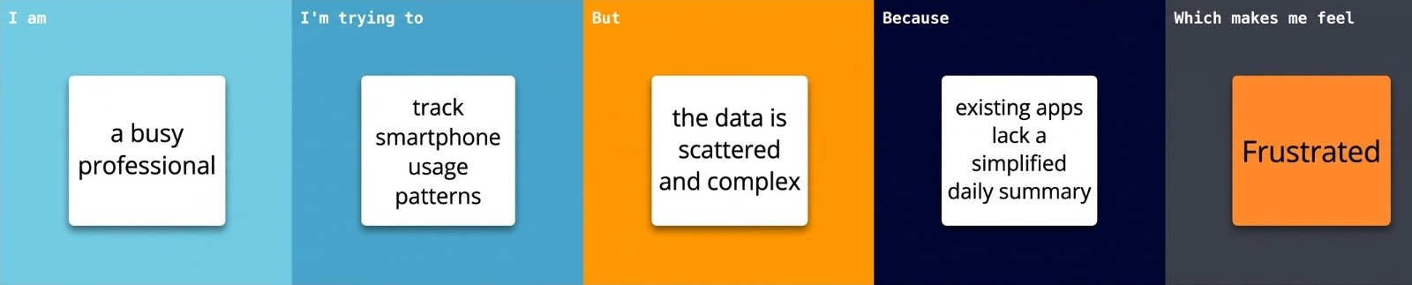
Problem Statements:
Problem  Statement (PS) | I am  (Customer) | I’m trying to | But | Because | Which makes me  feel
PS-1 | a product/research team | understand why 5,308 of 7,500 users (70.77%) are classified as addicted to smartphone usage | the overall addiction classification does not explain the key contributing factors | the available user data includes different behavioral, lifestyle, stress, and demographic characteristics | uncertain about where to focus analysis and well-being efforts
PS-2 | a product/research team | identify which factors most strongly correspond with smartphone addiction | it is difficult to prioritize well-being features and targeted interventions without clear evidence | screen-time behavior, lifestyle habits, stress, and demographic characteristics may have different relationships with addiction | concerned that digital-health interventions may not be targeted effectively

